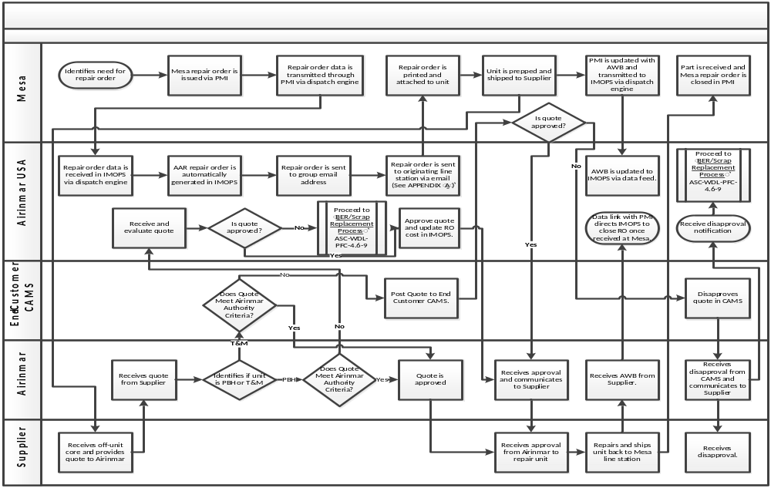

Appendix A

Mesa Line Stations

HNL | ORD | IAD
Go! Airlines HNL International Airport | Mesa Airlines – ORD | Mesa Airlines – IAD Stores
C/O Mesa Airlines | 750 Building 5A | 23321 Autopilot Drive
3012 Rogers Blvd. (Isle of Oahu) | Chicago, IL 60666 | Sterling, VA 20166
Honolulu, HI 96819
Email: hnlpartsdept@mesa-air.com | Email: ordparts@mesa-air.com | Email: iadparts@mesa-air.com
PHQ | TUS | CLT
Mesa Air Group – AIM | Mesa Airlines | Mesa Airlines
Attn: Receiving Department | 6900 S. Park Ave. | 4818 – D Express Drive
4346 E. Elmwood St. Unit #102 | Tucson, AZ 85756 | Charlotte, NC 28208
Phoenix, AZ 85040
Email: phxpartsdept@mesa-air.com | Email: tusparts@mesa-air.com | Email: #cltpartsdept@mesa-air.com
CKB
Bombardier Service Corp
West Virginia Air Center
2400 Aviation Way
Bridgeport, WV 26330
Email: #ckb@mesa-air.com | *********Heavy Check Base

